Sentiment Analysis on Movie Review

Abstract:
At present Sentiment analysis is the most discussed topic which is purposed to assist one to get important information from a large dataset. It centers on the investigation and comprehension of the feelings from the text patterns. It automatically characterizes the expression of feelings, e.g., negative, positive or neutral about the existence of anything. Various sources like medical, social media, newspaper, and movie review can be used in data analysis. Here, we have collected movie review data as well as used five kinds of machine learning classifiers to analyze these data. Hence, the considered classifiers are Bernoulli Naïve Bayes (BNB), Decision Tree (DE), Support Vector Machine (SVM), Maximum Entropy (ME), as well as Multinomial Naïve Bayes (MNB). Our analysis outlines that MNB achieves better accuracy, precision and F-score while SVM shows higher recall compared to others. Besides it also show that BNB Classifier achieves better accuracy than previous experiment over this classifier.
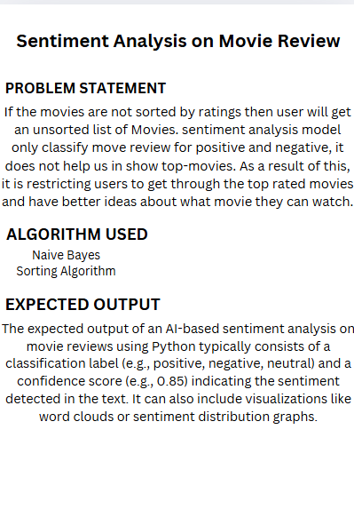

- SAI SAMSKRUTHI-2320030421
- HEMASAI-2320030169
- MEGHANA-2320030261

